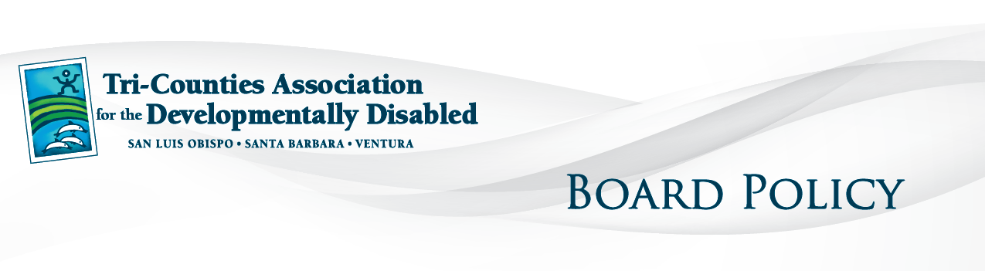
Policies and Guidelines - 9301

Approved by DDS: 2012 07 06

SERVICE POLICY GUIDELINES

Exploring and Securing Supports and Services
Tri-Counties Regional Center enhances the quality of life for persons with developmental disabilities by working with and advocating for persons with developmental disabilities and their families to secure those services which maximize opportunities and choices for living, learning, working, and pursuing recreational activities in the community.

Tri-Counties Regional Center employs a person centered planning process involving the individual and family or primary care givers as an integral part of the Planning Team. This process results in a written Individual Program Plan for each person served. Each person’s Individual Program Plan (IPP) records the supports and services determined by the Planning Team to be necessary to the achievement of their desired outcomes.
Tri-Counties Regional Center will ensure that the coordination of supports and services is centered on the individual and family of the individual with developmental disabilities and takes into consideration the needs and preferences of the individual, and family where appropriate, as well as promoting community integration, independent, productive and normal lives, and stable and healthy environments.

Tri-Counties Regional Center is committed to maximizing opportunities for the individual to develop relationships and to be a part of his/her community life in the areas of community participation such as housing, work, school, and leisure. Through these steps the person served will increase control over his or her life, acquire increasingly positive roles in community life, and develop competencies to accomplish these goals.

Tri-Counties Regional Center will give the highest preference to those supports and services that allow minors to live with their families, where appropriate, that allow adults to live as independently as possible in the community, and that allow all persons served to interact with persons without disabilities in positive and meaningful ways. Tri-Counties Regional Center will first consider supports and services in natural community, home, work and recreational settings. These supports and services will be flexible and individually tailored to the individual, or where appropriate, his or her family.

Tri-Counties Regional Center will provide or secure family support services that:
• respect and support the decision making authority of the family;
• are flexible and creative in meeting the unique and individual needs of the families as they evolve over time;
• recognize and build on family strengths, natural supports and existing community services;
• are designed to meet cultural preferences, values and lifestyles of families;
• focus on the entire family; and
• promote the inclusion of children with disabilities in all aspects of school and community.

For children with a developmental disability, this process will include a review of the strengths, preferences and needs of the child and family unit as a whole. Assessments will be conducted by qualified individuals and performed in natural environments whenever possible. The assessment process will reflect an awareness of, and sensitivity to, the lifestyle and cultural background of the child and the family.

The Planning Team will assist the person served and family to identify resources to be explored to provide the supports and services needed in order to achieve their desired outcomes. These resources may include but are not limited to: natural supports or natural community; generic resources; private entities including the family; and/or, regional center purchased supports and/or services.

Supports and/or services to be purchased on behalf of a person served or family member must be documented on the person’s Individual Program Plan and be authorized prior to the provision of the support and/or service. The Planning Team will specify on the Individual Program Plan document the duration and amount, the schedule for review of progress or effectiveness, for each support and/or service, and the approximate scheduled start date for services and supports and timelines for actions necessary to begin services and supports, including generic services. Individual Program Plans will be signed by a regional center representative and the person or, where appropriate, his or her parents, legal guardian, or conservator, shall sign the individual program plan prior to its implementation.

If the person or, where appropriate, his or her parents, legal guardian, or conservator, does not agree with all components of the plan, they may indicate that disagreement on the plan. Disagreement with specific plan components shall not prohibit the implementation of services and supports agreed to by the person or, where appropriate, his or her parents, legal guardian, or conservator. If the person or, where appropriate, his or her parents, legal guardian, or conservator, does not agree with the plan in whole or in part, he or she shall be sent written notice of the fair hearing rights.

No support or service provided by any agency or individual will be continued unless the individual, or where appropriate, his or her family or legal representative is satisfied or there is agreement that the planned supports and services have been provided and that reasonable progress toward objectives has been made. In some instances, the continuity of an authorized and funded support or service is critical to the person’s health and safety or to achieving an objective in their Individual Program Plan. In such situations the support and/or service may continue pending review by a Planning Team.

Clarification of terms:
Supports and services for persons with developmental disabilities are specialized supports and services or special adaptations of generic supports and services directed toward the alleviation of a developmental disability or toward the social, personal, physical or economic habilitation or rehabilitation of an individual with developmental disabilities, or toward the achievement and maintenance of independent, productive lives. Supports and services listed in the Individual Program Plan as delineated in the Lanterman Developmental Disabilities Services Act.

Exception Policy:
Tri-Counties Regional Center recognizes that some individual needs are so unique that they may not be addressed in this Service Policy and may require an exception. Such requests for an exception to a Service Policy will be made through the Planning Team process.

